**Mental Health Assistant 4+1 View**

**Panagiotis Papadopoulos & Kevin Zwick**

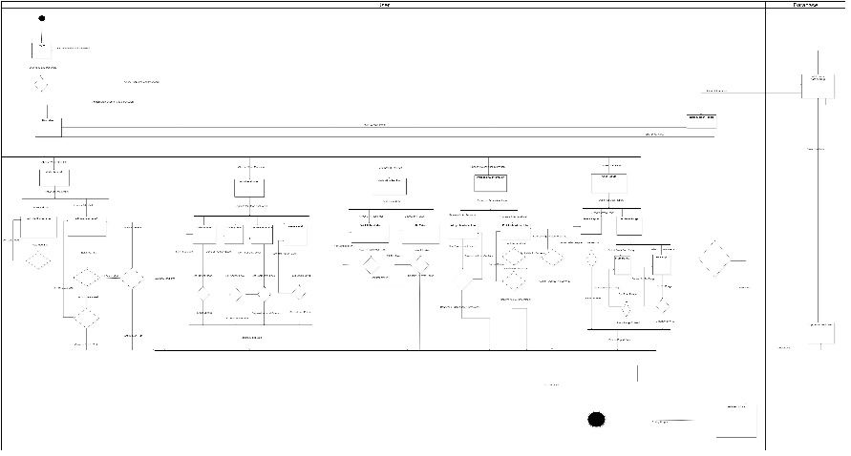 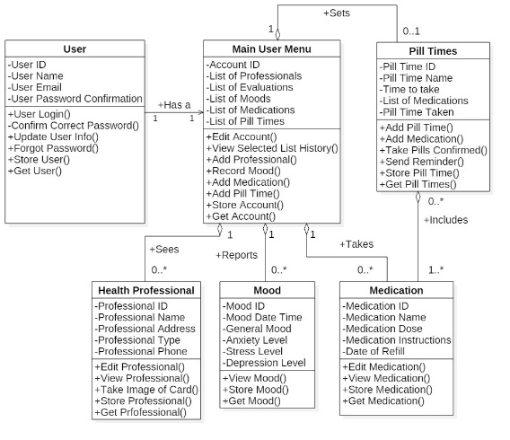

**Logical View** **Development View**

**Use Case**

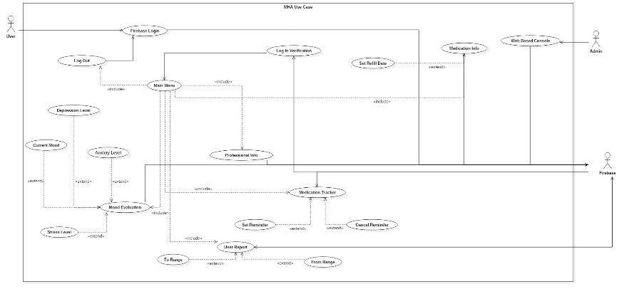

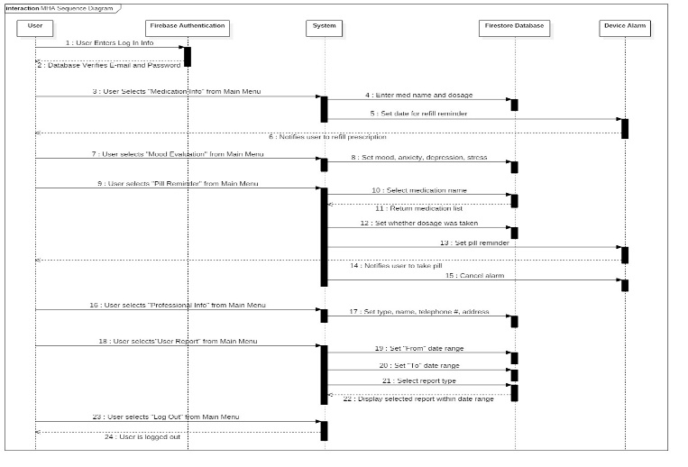 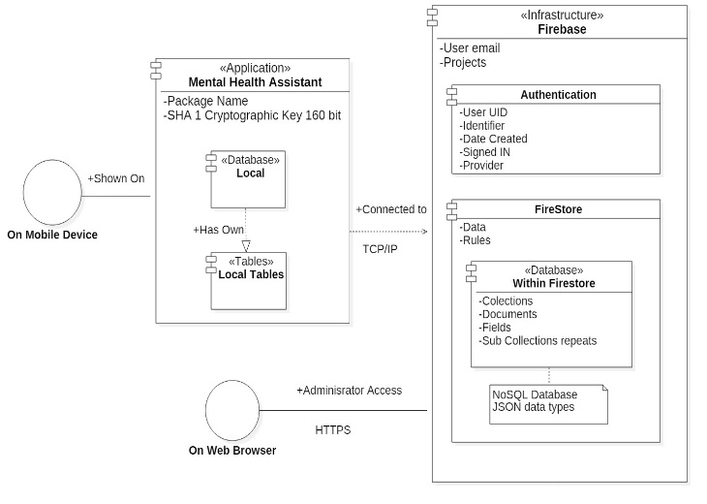

**Process View** **Physical View**